DATA HANDLING AND VISUALIZATION LABSHEETS

NAME: VAISHNAVI S ROLL NO: 20201ISB0010

# LABSHEET-1 INTRODUCTION TO NUMPY

import numpy as np a=np.array([1,2,3]) b=np.array([1,2,3])

add=np.add(a,b) add  array([2, 4,

6])

a=np.array([5,10,20])

b=np.array([4,8,10])

sub=np.subtract(a,b) sub  array([ 1, 2,

10])

a=np.array([5,10,20])

b=np.array([4,8,10])

sub=np.multiply(a,b) sub  array([ 20, 80,

200])

a=np.array([5,7,9]

)

b=np.array([4,5,6]

)

sub=np.mod(a,b) sub  array([1, 2,

3])

a=np.array([1,2,3])

b=np.array([1,2,3]) add=np.power(a,b) add  array([ 1, 4, 27])

## Series creation

import pandas as pd import numpy as np data=np.array(['a','b','c','d']) s=pd.Series(data) print(s)

|  |  |
| --- | --- |
| 0  1  2 | a  b |

|  |  |
| --- | --- |
| 3 | c  d |

dtype: object

## Series with index

import pandas as pd import numpy as np data=np.array(['a','b','c','d']) s=pd.Series(data,index=[101,102,103,104]) print(s)



|  |  |
| --- | --- |
| 101 | a |
| 102 | b |
| 103 | c |
| 104 | d |

dtype: object

## Series with Dictionary

import pandas as pd import numpy as np data={'a': 0.,'b': 1.,'c': 2.} s=pd.Series(data) print(s)

 a 0.0

b 1.0

c 2.0

dtype: float64

## Series with Dictionary with index

import pandas as pd import numpy as np data={'a': 0.,'b': 1.,'c': 2.}

s=pd.Series(data,index=['b','c','d','a']) print(s)

b

1.0 c

2.0 d

NaN a 0.0

dtype: float64

## Create Series from Scalar

import pandas as pd import numpy as np s= pd.Series(5, index=[0,1,2,3]) print(s)

0 5

1 5

2 5

3 5

dtype:

int64

## Retrieving data from the zeroth position

import pandas as pd

s= pd.Series([1,2,3,4,5],index=['a','b','c','d','e']) print(s[0]) 1

import pandas as pd s=

pd.Series([100,101,102,103,104,105,106,107,108,109,110],index=['a','b','c','d','e','f','

g ','h','i','j','k'])

print(s[:3]) a 100 b

101

c 102

dtype: int64

import pandas as pd s=

pd.Series([100,101,102,103,104,105,106,107,108,109,110],index=['a','b','c','d','e','f','

g ','h','i','j','k']) print(s[2:8])

 c

1. d
2. e
3. f
4. g
5. h 107

dtype: int64

## Using lable value

import pandas as pd s=

pd.Series([100,101,102,103,104,105,106,107,108,109,110],index=['a','b','c','d','e','f','

g ','h','i','j','k'])

print(s['a'])  100 import pandas as pd s=

pd.Series([100,101,102,103,104,105,106,107,108,109,110],index=['a','b','c','d','e','f','

g ','h','i','j','k'])

print(s[['a','e','i','d']])

a

100 e

104 i

108 d 103

dtype: int64

## Data Frames

import pandas as pd df=pd.read_csv("/content/nyc_weather.csv")

## Create data frame with empty data

import pandas as pd df=pd.DataFrame() print(df)

 Empty DataFrame Columns: [] Index: []

## Create data frame from list

import pandas as pd data=[1,2,3,4,5]

df=pd.DataFrame(data) print(df)

 0

0 1

1 2

2 3

3 4

4 5

import pandas as pd data=[['Alex',10],['Bob',12],['Clarke',13]]

df=pd.DataFrame(data,columns=['Name','Age']) print(df) Name Age

Alex 10

Bob 12

Clarke 13

import pandas as pd

data=[['Dha',21, 10001,'A'],['Sha',23, 10002,'B'],['Dee',22, 10003,'C']]

df=pd.DataFrame(data,columns=['Name','Age','Rollno','Sec'],dtype=float) print(df)  Name Age Rollno Sec

|  |  |  |  |
| --- | --- | --- | --- |
| 0 Dha | 21.0 | 10001.0 | A |
| 1 Sha | 23.0 | 10002.0 | B |
| 2 Dee | 22.0 | 10003.0 | C |

<ipython-input-31-f22448152035>:3: FutureWarning: Could not cast to float64, falling back to object. This behavior is deprecated. I df=pd.DataFrame(data,columns=['Name','Age','Rollno','Sec'],dtype=float)

## Cretae data frame from Dictionary

import pandas as pd data={'Name':['Tom','Jack','Steve','Ricky'],'Age':[23,25,22,29]

}

df=pd.DataFrame(data,index=['rank1','rank2','rank3','rank4']) print(df)

Name Age rank1 Tom 23 rank2

Jack 25 rank3

Steve 22 rank4

Ricky 29

# LABSHEET-2 WORKING WITH PANDAS

import pandas as pd

def load_data(): df_all = pd.read_csv('/content/train.csv')

return df_all.loc[:300,['Survived','Pclass','Sex','Cabin','Embarked']].dropna() df=load_data()

df.head()

 **Survived Pclass Sex Cabin Embarked**

|  |  |  |  |
| --- | --- | --- | --- |
| **0** | 0 | 1 | male C30 S |
| **1** | 1 | 1 | female D33 C |
| **9** | 1 | 3 | male E121 S |
| **10** | 1 | 1 | female B22 S |
| **14** | 0 | 1 | male B51 B53 B55 S |

## FINDING DUPLICATE ROWS

df.Cabin.duplicated()

False False

|  |  |
| --- | --- |
| 9 | False |
| 10 | False |
| 14  ... | False |
| 271 | False |
| 278 | False |
| 286 | False |

False False

Name: Cabin, Length: 80, dtype: bool

df.duplicated()

False False

|  |  |
| --- | --- |
| 9 | False |
| 10 | False |
| 14  ... | False |
| 271 | False |
| 278 | False |
| 286 | False |

False False

Length: 80, dtype: bool

df.duplicated(subset=['Survived','Pclass','Sex'])

False False

|  |  |
| --- | --- |
| 9 | False |
| 10 | True |
| 14  ... | True |
| 271 | True |
| 278 | True |

|  |  |
| --- | --- |
| 286 | True |
| 299 | True |
| 300 | True |

Length: 80, dtype: bool

## COUNTING DUPLICATES AND NON DUPLICATES

df.Cabin.duplicated().sum() 

11 df.duplicated().sum() 3



df.duplicated(subset=['Survived','Pclass','Sex']).sum()  70

(~df.duplicated()).sum()  77 EXTRACTING DUPLICATE ROWS USING LOC

df.loc[df.duplicated(), :]

**Survived Pclass Sex Cabin Embarked**

|  |  |  |
| --- | --- | --- |
| **138** | 1 2 female F33 | S |
| **169** | 1 1 female B77 | S |
| **237** | 1 1 female B96 B98 | S |

## USING KEEP

df.loc[df.duplicated(keep='first'), :]

**Survived Pclass Sex Cabin Embarked**

|  |  |
| --- | --- |
| **138** 1 2 female F33 | S |
| **169** 1 1 female B77 | S |
| **237** 1 1 female B96 B98 | S |

df.loc[df.duplicated(keep='last'), :]

**Survived Pclass Sex Cabin Embarked**

|  |  |
| --- | --- |
| **36** 1 1 female B77 | S |
| **77** 1 1 female B96 B98 | S |
| **134** 1 2 female F33 | S |

df.loc[df.duplicated(keep=False), :]

**Survived Pclass Sex Cabin Embarked**

|  |  |  |  |
| --- | --- | --- | --- |
| **36** | 1 | 1 female B77 | S |
| **77** | 1 | 1 female B96 B98 | S |
| **134** | 1 | 2 female F33 | S |
| **138** | 1 | 2 female F33 | S |
| **169** | 1 | 1 female B77 | S |
| **237** | 1 | 1 female B96 B98 | S |

## DROPPING DUPLICATED ROWS

df.drop_duplicates()



|  |  |  |  |  |  |  |  |
| --- | --- | --- | --- | --- | --- | --- | --- |
|  | **Survived** | **Pclass** |  | **Sex Cabin Embarked** | | | |
| **0** | 0 |  | 1 | male C30 S | | | |
| **1** | 1 |  | 1 | female D33 C | | | |
| **9** | 1 |  | 3 | male E121 S | | | |
| **10** | 1 |  | 1 | female B22 S | | | |
| **14** | 0 | 1 |  | male B51 B53 B55 S | | | |
| **...** | ... | ... |  | ... |  | ... | ... |
| **271** | 1 | 1 |  | male |  | C93 | S |
| **278** | 0 | 1 |  | male |  | C111 | C |
| **286** | 1 | 1 |  | male |  | C148 | C |
| **299** | 1 |  | 1 |  | female | D21 | S |
| **300** | 1 |  | 2 |  | male | F2 | S |

77 rows × 5 columns

df.drop_duplicates(keep=False)

**Survived Pclass Sex Cabin Embarked**

|  |  |  |  |  |  |
| --- | --- | --- | --- | --- | --- |
| **0** | 0 | 1 | male | C30 | S |
| **1** | 1 | 1 | female | D33 | C |
| **9** | 1 | 3 | male | E121 | S |
| **10** | 1 | 1 | female | B22 | S |
| **14** | 0 | 1 | male | B51 B53 B55 | S |
| **...** | ... | ... | ... | ... | ... |
| **271** | 1 | 1 | male | C93 | S |
| **278** | 0 | 1 | male | C111 | C |
| **286** | 1 | 1 | male | C148 | C |
| **299** | 1 | 1 | female | D21 | S |
| **300** | 1 | 2 | male | F2 | S |

74 rows × 5 columns

# LABSHEET-3 DATA CLEANING

import pandas as pd import numpy as np

df=pd.read_csv('/content/2,1 dataset titanic.csv')

cols=['Name','Ticket','Cabin'] df=df.drop(cols,axis=1) df.info()

 <class 'pandas.core.frame.DataFrame'> RangeIndex: 891 entries, 0 to 890 Data columns (total 9 columns):

# Column Non-Null Count Dtype

1. PassengerId 891 non-null int64
2. Survived 891 non-null int64
3. Pclass 891 non-null int64
4. Sex 891 non-null object
5. Age 714 non-null float64
6. SibSp 891 non-null int64
7. Parch 891 non-null int64
8. Fare 891 non-null float64

8 Embarked 889 non-null object dtypes: float64(2), int64(5), object(2) memory usage: 62.8+ KB

df=df.dropna() df.info()

 <class 'pandas.core.frame.DataFrame'> Int64Index: 712 entries, 0 to 890 Data columns (total 9 columns):

# Column Non-Null Count Dtype

1. PassengerId 712 non-null int64
2. Survived 712 non-null int64
3. Pclass 712 non-null int64
4. Sex 712 non-null object
5. Age 712 non-null float64
6. SibSp 712 non-null int64
7. Parch 712 non-null int64
8. Fare 712 non-null float64

8 Embarked 712 non-null object dtypes: float64(2), int64(5), object(2) memory usage: 55.6+ KB dummies=[] cols=['Pclass','Sex','Embarked'] for col in cols: dummies.append(pd.get_dummies(df[col]))

titanic_dummies= pd.concat(dummies,axis=1) df= pd.concat((df,titanic_dummies), axis=1)

df= df.drop(['Pclass','Sex','Embarked'],axis=1)

df['Age'] = df['Age'].interpolate() print(df)

 PassengerId Survived Age SibSp Parch Fare 1 2 3 female \

|  |  |  |  |  |
| --- | --- | --- | --- | --- |
| 0 1 | 0 22.0 | 1 | 0 7.2500 0 0 1 | 0 |
| 1 2 | 1 38.0 | 1 | 0 71.2833 1 0 0 | 1 |
| 2 3 | 1 26.0 | 0 | 0 7.9250 0 0 1 | 1 |
| 3 4 | 1 35.0 | 1 | 0 53.1000 1 0 0 | 1 |

4 5 0 35.0 0 0 8.0500 0 0 1 0 .. ... ... ... ... ... ... .. .. .. ... 885 886 0 39.0 0 5 29.1250 0 0 1 1

886 887 0 27.0 0 0 13.0000 0 1 0 0

|  |  |  |  |  |
| --- | --- | --- | --- | --- |
| 887 | 888 | 1 19.0 | 0 0 30.0000 1 0 0 | 1 |
| 889 | 890 | 1 26.0 | 0 0 30.0000 1 0 0 | 0 |
| 890 | 891 | 0 32.0 | 0 0 7.7500 0 0 1 | 0 |

male C Q S 0 1 0

0 1

|  |  |  |
| --- | --- | --- |
| 1 | 0 | 1 0 0 |
| 2 | 0 | 0 0 1 |
| 3 | 0 | 0 0 1 |
| 4 | 1 | 0 0 1 |

.. ... .. .. ..

885 0 0 1 0

886 1 0 0 1

887 0 0 0 1

889 1 1 0 0

890 1 0 1 0

[712 rows x 14 columns]

## MIN MAX SCALAR STANDARDIZATION

from sklearn.preprocessing import MinMaxScaler data=[[-1,2],[-0.5,6],[0,10],[1,18]] scaler=MinMaxScaler()

|  |  |
| --- | --- |
| print(scaler.fit(data)) print('  MinMaxScaler() | ') |
| print(scaler.data_max_) print('  print('scaler.transform(data)') | ') |

MinMaxScaler() [ 1. 18.]

scale~~r.tra~~nsform(data)

from numpy import asarray

from sklearn.preprocessing import StandardScaler data=asarray([[100,0.001], [8,0.05],

[50,0.005],

[88,0.07],

[4,0.1]])

print(data)

scaler= StandardScaler()

scaled = scaler.fit_transform(data) print(scaled)

 [[1.0e+02 1.0e-03]

[8.0e+00 5.0e-02]

[5.0e+01 5.0e-03]

[8.8e+01 7.0e-02]

[4.0e+00 1.0e-01]]

[[ 1.26398112 -1.16389967]

[-1.06174414 0.12639634]

[ 0. -1.05856939]

[ 0.96062565 0.65304778]

[-1.16286263 1.44302493]]

from sklearn.preprocessing import MinMaxScaler data=[[-1,2],[-0.5,6],[0,10],[1,18]] scaler=MinMaxScaler()

print(scaler.fit(data)) MinMaxScaler() print(scaler.data_max_) print('scaler.transform(data)')

 MinMaxScaler() [ 1. 18.] scaler.transform(data)

# LABSHEET-4 Z-SCORE NORMALIZATION

import numpy as np data= [1,2,2,2,3,1,1,15,2,2,2,3,1,1,2]

mean= np.mean(data) std= np.std(data)

print("mean of the dataset ids", mean) print("std is", std) threshold=3 outlier=[] for i in data: z=(i-mean)/std if z>threshold: outlier.append(i)

print("outlier in dataset is", outlier)

 mean of the dataset ids 2.6666666666666665 std is 3.3598941782277745

outlier in dataset is [15]

# LABSHEET-5 OUTLIER DETECTION WITH IQR

import numpy as np import seaborn as sns data=[6,2,3,4,5,1,50]

sort_data=np.sort(data) sort_data  array([ 1, 2, 3, 4, 5, 6, 50])

Q1=-np.percentile(data, 25, interpolation = 'midpoint') Q2=-np.percentile(data, 50, interpolation = 'midpoint') Q3=-np.percentile(data, 75, interpolation = 'midpoint')

print('Q1 25 percentile of the given data is, ', Q1) print('Q2 50 percentile of the given data is, ', Q2) print('Q3 75 percentile of the given data is, ', Q3)

IQR = Q3 - Q1

print('IQR is', IQR)

 Q1 25 percentile of the given data is, -2.5 Q2 50 percentile of the given data is,

4.0 Q3 75 percentile of the given data is, -5.5 IQR is -3.0 low_lim = Q1 - 1.5 * IQR up_lim = Q3 + 1.5 * IQR

# LABSHEET-6 MATPLOTLIB

import pandas as pd import numpy as np import matplotlib.pyplot as plt

df=pd.read_csv("/content/Toyota.csv", index_col = 0, na_values = ['??','???']) df.info()

 <class 'pandas.core.frame.DataFrame'> Index: 1436 entries, 0 to 1435

Data columns (total 10 columns):

# Column Non-Null Count Dtype

0 Price 1436 non-null int64

|  |  |  |
| --- | --- | --- |
| 1 | Age 1336 non-null float64 |  |
| 2 | KM 1421 non-null float64 |  |
| 3 | FuelType 1336 non-null object |  |
| 4 | HP 1436 non-null object |  |
| 5 | MetColor 1286 non-null float64 |  |
| 6 | Automatic 1436 non-null int64 |  |
| 7 | CC 1436 non-null int64 |  |
| 8 | Doors 1436 non-null object |  |
| 9 | Weight 1436 non-null int64 |  |
| dtypes: | float64(3), int64(4), object(3) memory usage: 123.4+ | KB |

df.dropna(axis=0,inplace=True) df

**Price Age KM FuelType HP MetColor Automatic CC Doors Weight**

**0** 13500 23.0 46986.0 Diesel 90 1.0 0 2000

three 1165

**1** 13750 23.0 72937.0 Diesel 90 1.0 0 2000

3 1165

**3** 14950 26.0 48000.0 Diesel 90 0.0 0 2000

3 1165

**4** 13750 30.0 38500.0 Diesel 90 0.0 0 2000

3 1170

**5** 12950 32.0 61000.0 Diesel 90 0.0 0 2000

3 1170

**...** ... ... ... ... ... ... ... ... ... ...

|  |  |  |  |  |  |  |  |
| --- | --- | --- | --- | --- | --- | --- | --- |
| **1423** | 7950 | 80.0 35821.0 | Petrol | 86 | 0.0 | 1 | 1300 |
|  | 3 | 1015 |  |  |  |  |  |
| **1424** | 7750 | 73.0 34717.0 | Petrol | 86 | 0.0 | 0 | 1300 |
|  | 3 | 1015 |  |  |  |  |  |
|  | **1429** 8950 | 78.0 24000.0 | Petrol | 86 | 1.0 | 1 | 1300 |
| 5 | 1065 |  |  |  |  |  |  |

**1430** 8450 80.0 23000.0 Petrol 86 0.0 0 1300 3 1015 **1435** 6950 76 0 1.0 Petrol 110 0.0 0

1600 5 1114 1099 rows × 10 columns

## SCATTER PLOT

plt.scatter(df['Age'], df['Price'], c='red') plt.title('Scatter plot of price vs age') plt.xlabel('Age(Month)') plt.ylabel('Price(Euros)') plt.show()

 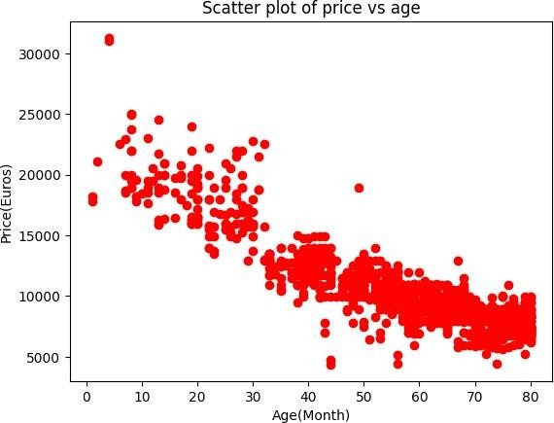

## HISTOGRAM

plt.hist(df['KM'])

 (array([ 93., 239., 331., 223., 111., 52., 25., 13., 10., 2.]), array([1.000000e+00, 2.430090e+04, 4.860080e+04, 7.290070e+04,

9.720060e+04, 1.215005e+05, 1.458004e+05, 1.701003e+05,

1.944002e+05, 2.187001e+05, 2.430000e+05]),

<BarContainer object of 10 artists>)

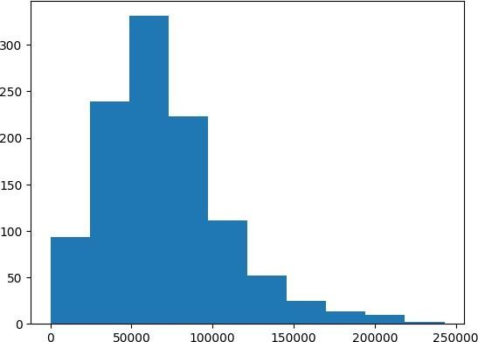

plt.hist(df['FuelType'])

(array([117., 0., 0., 0., 0., 970., 0., 0., 0., 12.]),

array([0. , 0.2, 0.4, 0.6, 0.8, 1. , 1.2, 1.4, 1.6, 1.8, 2. ]),

<BarContainer object of 10 artists>)

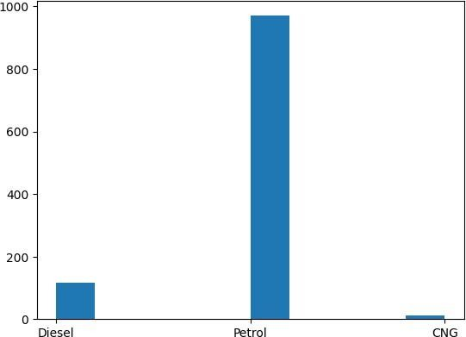

plt.hist(df['KM'],color='pink',edgecolor='white',bins=30) plt.title('Histogram of KM') plt.xlabel('Kilometers') plt.ylabel('Frequency') plt.show()

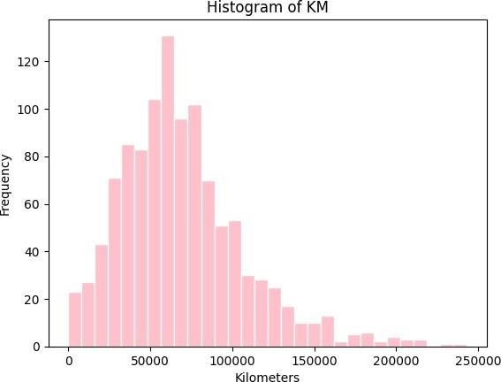

## BAR PLOT

counts = [979,120,2] fueltype= ('Petrol','Diesel','CNG') index= np.arange(len(fueltype))

plt.bar(index,counts,color=['red','blue','cyan']) plt.title('Bar plot of fuel type') plt.xlabel('Fuel Types') plt.ylabel('Frequency') plt.xticks(index, fueltype, rotation= 60) plt.show()

 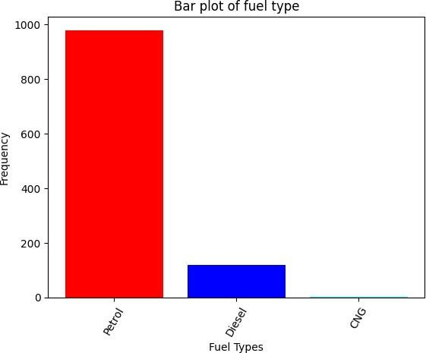

## LINE PLOT

fig, axes = plt.subplots(1, 2, figsize=(10,4)) x=df['KM'] axes[0].plot(x, x**2, x, np.exp(x)) axes[0].set_title("Normal Scale")

axes[1].plot(x, x**2, x, np.exp(x)) axes[1].set_yscale("log") axes[1].set_title("Logarithmic scale (y)")

 /usr/local/lib/python3.10/dist-packages/pandas/core/arraylike.py:396: RuntimeWarning: overflow encountered in exp result = getattr(ufunc, method)(*inputs,

**kwargs) Text(0.5, 1.0, 'Logarithmic scale (y)')

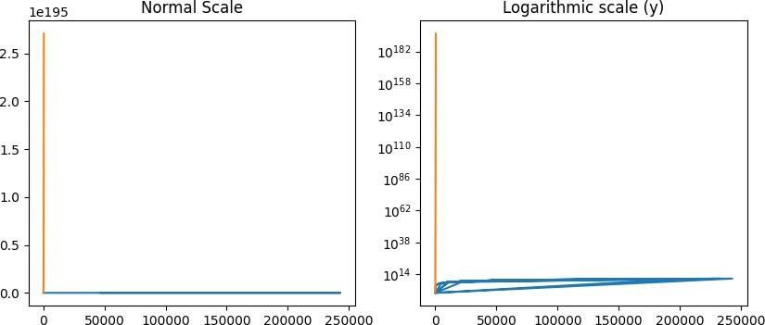

fig, ax = plt.subplots(figsize=(10,4)) x=df['KM'] ax.plot(x, x**2,x,x**3, lw=2) ax.set_xticks([1,2,3,4,5])

ax.set_xticklabels([r'$/alphas',r'$/beta$',r'$/gamma$',r'$/delta$', r'$/epsilon$'], fontsize=18) yticks=[0,50,100,150] ax.set_yticks(yticks) ax.set_yticklabels(["$%.1f$" % y for y in yticks])

[Text(0, 0, '$0.0$'),

Text(0, 50, '$50.0$'),

Text(0, 100, '$100.0$'),

Text(0, 150, '$150.0$')]

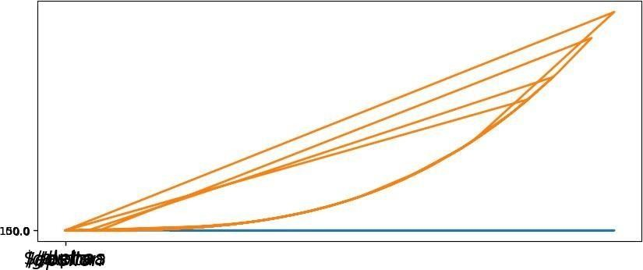

fig, ax= plt.subplots(1,1) x=df['KM'] ax.plot(x, x**2, x, np.exp(x))

ax.set_title("scientific notation") ax.set_yticks([0,50,100,150]) from matplotlib import ticker

formatter = ticker.ScalarFormatter(useMathText=True) formatter.set_scientific(True) formatter.set_powerlimits((-1,1)) ax.yaxis.set_major_formatter(formatter)

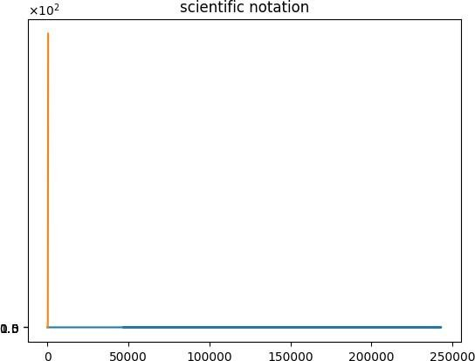

import matplotlib matplotlib.rcParams['xtick.major.pad'] =

5 matplotlib.rcParams['ytick.major.pad']

= 5

x = df['KM']

fig, ax = plt.subplots(1, 1)

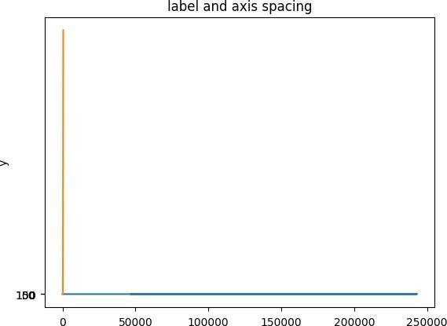ax.plot(x, x**2, x, np.exp(x)) ax.set_yticks([0, 50, 100, 150]) ax.set_title("label and axis spacing") ax.xaxis.labelpad = 5 ax.yaxis.labelpad = 5 ax.set_ylabel("x") ax.set_ylabel("y") plt.show()  /usr/local/lib/python3.10/dist- packages/pandas/core/arraylike.py:396: RuntimeWarning: overflow encountered in exp result = getattr(ufunc, method)(*inputs, **kwargs)

import matplotlib matplotlib.rcParams['xtick.major.pad'] = 3

matplotlib.rcParams['ytick.major.pad'] = 3

# LABSHEET-7 INTERACTING WITH WEB API

import requests

pip install --upgrade 'library'  Collecting library

Downloading Library-0.0.0.tar.gz (1.4 kB) Preparing metadata (setup.py) ... done Building wheels for collected packages: library

Building wheel for library (setup.py) ... done

Created wheel for library: filename=Library-0.0.0-py3-none-any.whl size=2054 sha256=33e04a1cd46e5d3b86146af77a7e80978fe44edaeba4a Stored in directory:

/root/.cache/pip/wheels/e0/71/7d/b0e29b944e43374597cd4e3b88c85197001c9bfcd5dce191f4 Successfully built library

Installing collected packages: library Successfully installed library-0.0.0

r = requests.get('[https://www.romexchange.com/'](http://www.romexchange.com/%27)))

r

 <Response [406]>

r.status_code  406 url = ['https://www.romexchange.com/'](http://www.romexchange.com/%27)

headers = {'Content-type': 'application/json'}

ur l

 ['https://www.romexchange.com/'](http://www.romexchange.com/%27) header

s

 {'Content-type': 'application/json'} r=requests.get(url, headers = headers) url = ['https://www.romexchange.com/'](http://www.romexchange.com/%27)

headers = {'User-Agent': 'XY','Content-type': 'application/json'} r = requests.get(url, headers=headers)

url

 ['https://www.romexchange.com/'](http://www.romexchange.com/%27) header

s

 {'User-Agent': 'XY', 'Content-type': 'application/json'} r

 <Response [200]>

r.status_code  200 url = ['https://www.romexchange.com/api?item=mastela&exact](http://www.romexchange.com/api?item=mastela&exact=false%27)=false' headers =

{'UserAgent':'XY','Content-type':'application/json'}

r= requests.get(url, headers=headers) r.status_code

 500

r.text

 ''

# LABSHEET-8 COLORMAPS

import pandas as pd import numpy as np import matplotlib.pyplot as plt

#sample datafame with multiple columns data=pd.DataFrame({"x":np.random.randn(100),"y":np.random.randn(100),"value":np.random. ran dn(100)}) #define the colormap and alpha values cmap="viridis" alpha=1 #create the scatterplot plt.figure(figsize=(6,6)) plt.scatter(data["x"],data["y"],c=data["value"],cmap=cmap,alpha=alpha) #customize the plot(optional)

plt.xlabel("X-axis") plt.ylabel("Y-axis")

plt.title("Scatterplot with colormap") plt.colorbar(label="value") #show the plot plt.show()

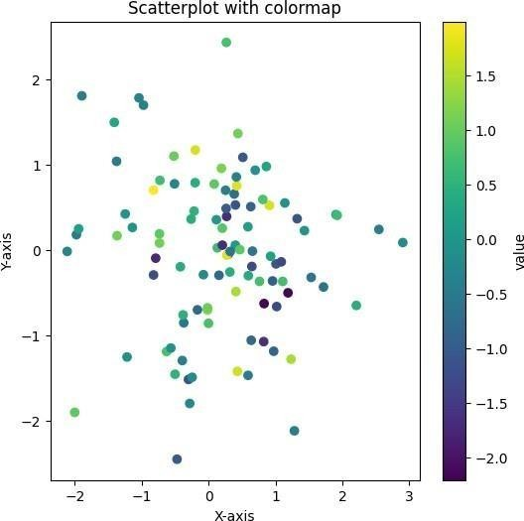

import pandas as pd import numpy as np print(np.random.randn(100))

 [-1.65970274e-01 -3.26301492e-01 -6.97091694e-01 5.29185683e-01 1.65900203e-01 2.57310809e-01 1.87945887e-01 -1.47856355e+00

1.85465880e+00 -5.74773399e-02 -7.28047219e-01 1.43513290e+00 1.16276640e-

01 3.62925427e-01 2.27296732e-01 -4.68725785e-01

-7.20465601e-01 2.31190101e-01 5.47647007e-01 6.14310198e-01

-2.88178116e-01 -2.59650445e-01 7.14726089e-02 2.91407763e-01 7.44199514e-01 1.03744520e+00 5.19583750e-02 -1.22315192e+00

2.82553552e-01 9.27484581e-01 4.68496647e-01 3.97669795e-01

-6.15495640e-01 -3.59199216e-01 1.45247374e-01 -1.61267440e-01

-1.08796055e+00 2.03942727e-01 1.33177945e-03 7.08911052e-01 1.92045492e+00 1.06460553e+00 9.71054014e-01 8.14301945e-01

1.01645092e-01 -9.38076692e-02 1.33631841e+00 2.55274328e-01

-5.17379367e-01 -1.71773916e+00 9.24194703e-01 1.67657214e-01

-1.72214971e+00 4.27042698e-01 -1.20346437e+00 2.83589309e-01 1.21334367e+00 4.14428011e-02 -1.48913563e+00 4.39560682e-01

-8.90366916e-01 -9.11298844e-01 3.62446399e-01 5.87632377e-01 1.22152619e+00 7.44396580e-01 1.75575979e+00 3.12178887e-01

-3.40512410e-01 -1.01818680e+00 4.62977518e-02 2.30443390e-01

-3.96879315e-01 1.20713778e+00 -1.20064064e+00 -9.12708432e-01 9.06172668e-01 7.05249075e-02 -9.42170303e-01 -8.52966288e-01

1.96198904e+00 3.61012540e-02 9.66762176e-01 -4.97875528e-01

2.78681896e-01 -1.16708383e+00 7.39087305e-01 1.27038245e+00

7.81304235e-01 -4.62440127e-01 1.00117969e+00 -9.07298230e-02

-1.95950298e-01 1.59291286e+00 -1.22572212e+00 -4.62563405e-01 5.41920487e-01 7.41261996e-01 1.42219990e+00 -9.65150475e-01]

import pandas as pd import numpy as np import matplotlib.pyplot as plt

#sample datafame with multiple columns data=pd.DataFrame({"x":np.random.randn(100),"y":np.random.randn(100),"value":np.random. ran dn(100)}) #define the colormap and alpha values cmap="viridis" alpha=1 #create the scatterplot plt.figure(figsize=(8,8)) plt.scatter(data["x"],data["y"],c=data["value"],cmap=cmap,alpha=alpha) #customize the plot(optional)

plt.xlabel("X-axis") plt.ylabel("Y-axis")

plt.title("Scatterplot with colormap") plt.colorbar(label="value") #show the plot plt.show()

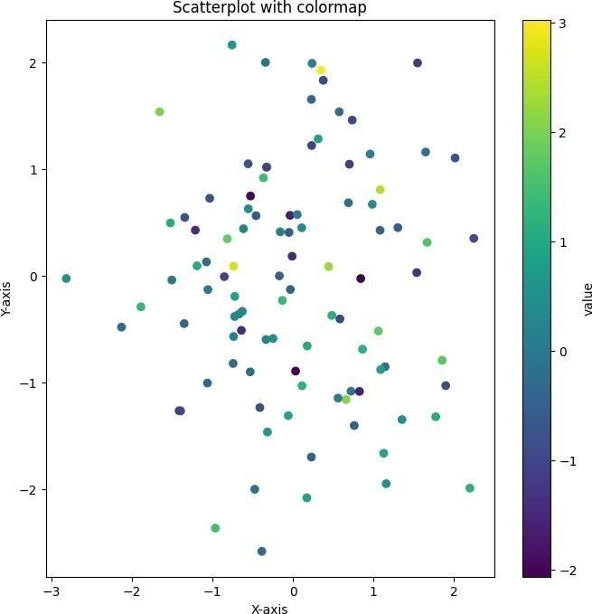

# LABSHEET-9 HEATMAPS

import numpy as np

import matplotlib.pyplot as plt data= np.random.random((13,16)) plt.imshow( data,cmap="magma") plt.title("2D Heatmap") plt.colorbar() plt.show()

 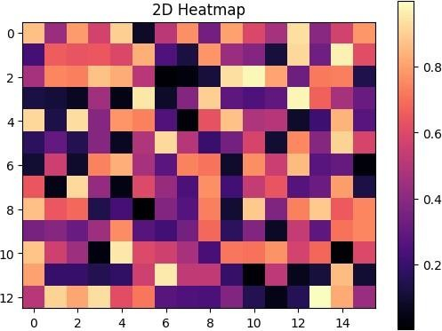

import numpy as np

import matplotlib.pyplot as plt data=np.random.random((12,12)) plt.imshow(data, cmap='autumn')

plt.title("Heatmap with different color") plt.show()

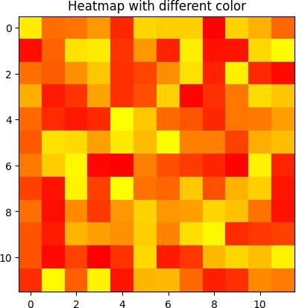

import numpy as np import seaborn as sns import matplotlib.pyplot as plt

data= np.random.randint(low=14,high=100, size=(10,10)) hm=sns.heatmap(data=data, annot=True) plt.show()

 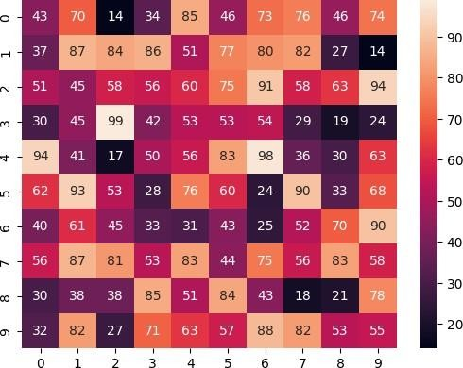

import pandas as pd import numpy as np df=pd.read_csv('/content/train.csv')

df= np.random.randint(low=55, high=60, size=(8,8))

hm=sns.heatmap(data=data, annot=True) plt.show()

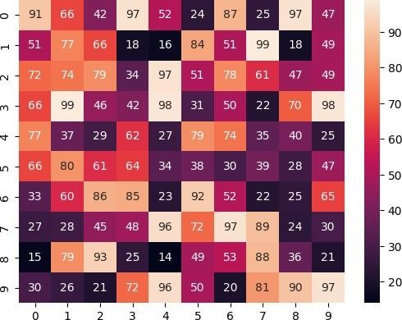

# LABSHEET-10 SEABORN COLOR PALLETTES

import numpy as np import pandas as pd

import matplotlib.pyplot as plt import seaborn as sns

%matplotlib inline sns.set(rc={"figure.figsize": (6,6)})

## BUILDING COLOR PALLETTES

current_palette = sns.color_palette() sns.palplot(current_palette)

 

sns.palplot(sns.color_palette("hls", 8))



sns.palplot(sns.color_palette("husl", 8))



sample_colors = ["windows blue", "amber", "greyish", "faded green", "dusty purple", "pale red", "medium green", "denim blue"] sns.palplot(sns.xkcd_palette(sample_colors))



sns.palplot(sns.color_palette("cubehelix", 8))



sns.palplot(sns.cubehelix_palette(8))



x,y = np.random.multivariate_normal([0,0], [[1,-.5],[-.5,1]], size=300).T sample_cmap = sns.cubehelix_palette(light=1, as_cmap=True)

sns.kdeplot(x=x,y=y,cmap=sample_cmap, shade=True)

<ipython-input-16-534ef71d14c3>:3: FutureWarning:

`shade` is now deprecated in favor of `fill`; setting `fill=True`. This will become an error in seaborn v0.14.0; please update your code.

sns.kdeplot(x=x,y=y,cmap=sample_cmap, shade=True)

<Axes: >

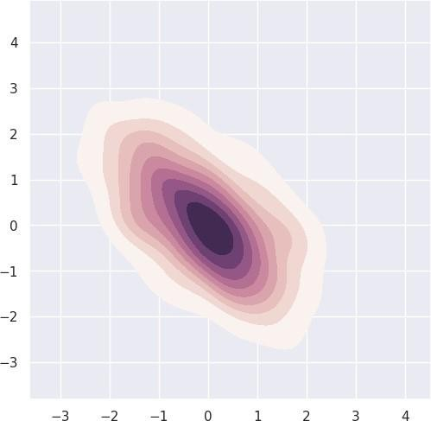

sns.choose_cubehelix_palette(as_cmap=True)

|  |  |  |
| --- | --- | --- |
| n_colors |  | 7 |
| start |  | 1.10 |
| rot |  | 0.10 |
| gamma |  | 1.40 |
| hue |  | 0.80 |
| light dark | 0.40 | 0.85 |

reverse



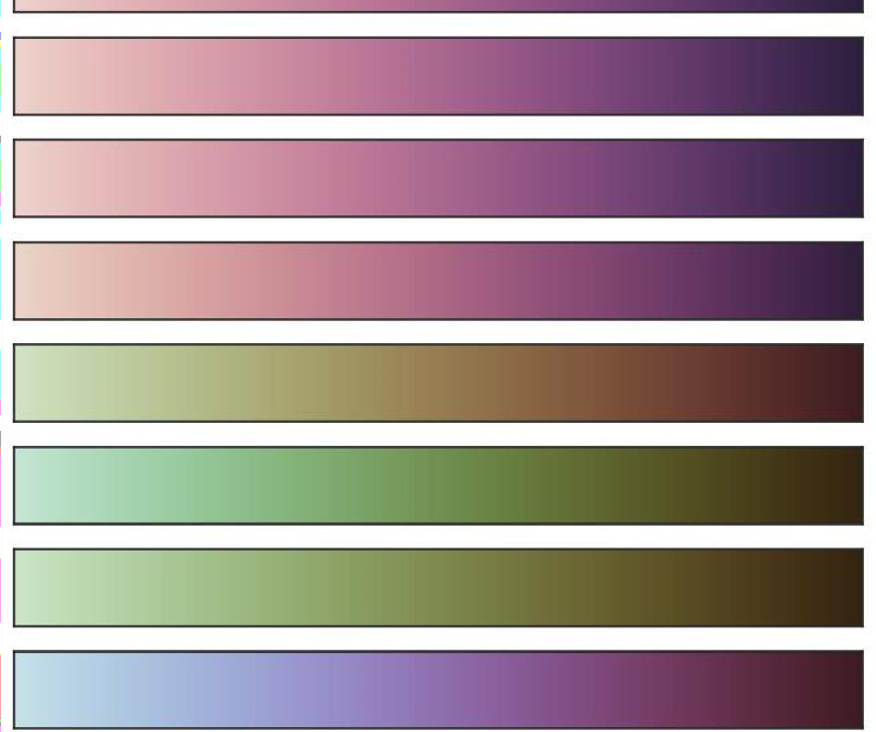interactive under

bad over



sns.set_style('whitegrid')

sns.swarmplot(x="day", y="total_bill", data=tips, palette="viridis")  <ipython-input- 23-1576c2e5eda7>:2: FutureWarning:

Passing `palette` without assigning `hue` is deprecated and will be removed in v0.14.0. Assign the `x` variable to `hue` and set `l sns.swarmplot(x="day", y="total_bill", data=tips, palette="viridis")

<Axes: xlabel='day', ylabel='total_bill'>

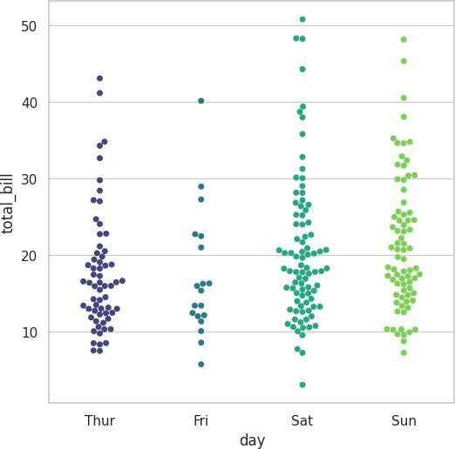

sns.set_style('whitegrid')

sns.swarmplot(x="day", y="total_bill", data=tips, palette="plasma")  <ipython-input-24- 8931cda8de8a>:2: FutureWarning:

Passing `palette` without assigning `hue` is deprecated and will be removed in v0.14.0. Assign the `x` variable to `hue` and set `l sns.swarmplot(x="day", y="total_bill", data=tips, palette="plasma")

<Axes: xlabel='day', ylabel='total_bill'>

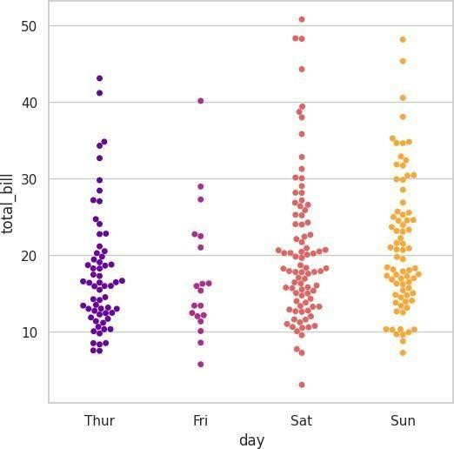

iris = sns.load_dataset("iris")

sns.boxplot(x="species", y="petal_length", data=iris, palette="cividis")  <ipython-input-26-cc37ff1b7cba>:2: FutureWarning:

Passing `palette` without assigning `hue` is deprecated and will be removed in v0.14.0. Assign the `x` variable to `hue` and set `l sns.boxplot(x="species", y="petal_length", data=iris, palette="cividis")

<Axes: xlabel='species', ylabel='petal_length'>

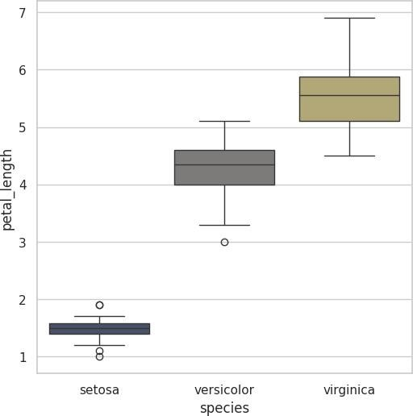

iris = sns.load_dataset("iris")

sns.boxplot(x="species", y="petal_length", data=iris, palette="plasma")  <ipython- input-27-0b4fe890c1f3>:2: FutureWarning:

Passing `palette` without assigning `hue` is deprecated and will be removed in v0.14.0. Assign the `x` variable to `hue` and set `l sns.boxplot(x="species", y="petal_length", data=iris, palette="plasma")

<Axes: xlabel='species', ylabel='petal_length'>

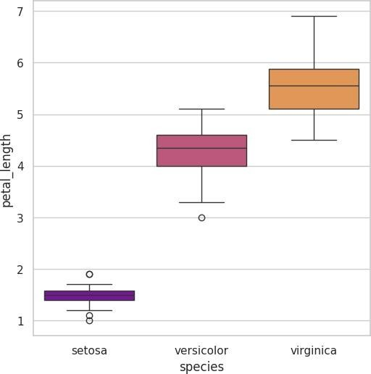

iris = sns.load_dataset("iris")

sns.boxplot(x="species", y="petal_length", data=iris, palette="inferno")  <ipython-input-28-e860428b94f7>:2: FutureWarning:

Passing `palette` without assigning `hue` is deprecated and will be removed in v0.14.0. Assign the `x` variable to `hue` and set `l sns.boxplot(x="species", y="petal_length", data=iris, palette="inferno")

<Axes: xlabel='species', ylabel='petal_length'>

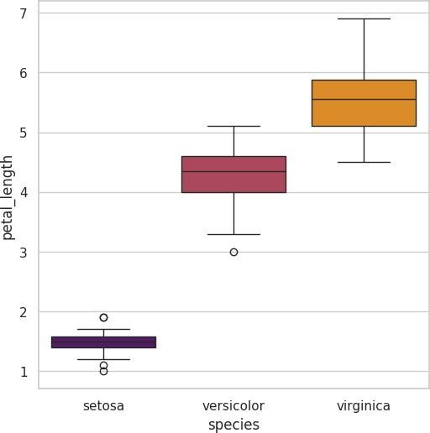

iris = sns.load_dataset("iris")

sns.boxplot(x="species", y="petal_length", data=iris, palette="magma")  <ipython-input- 29-ebb177fa7cb5>:2: FutureWarning:

Passing `palette` without assigning `hue` is deprecated and will be removed in v0.14.0. Assign the `x` variable to `hue` and set `l sns.boxplot(x="species", y="petal_length", data=iris, palette="magma")

<Axes: xlabel='species', ylabel='petal_length'>

# LABSHEET-11 MULTIVARIATE VISUALIZATION

Relational plots: relation b/w two variables categorical plots: categorical values are displayed

distribution plots: examining univariate and bivariate distributions matrix plots: array of scatterplots

Regression plots: emphasixe patterns in dataset during exploratory data analysis

import numpy as np import pandas as pd import matplotlib.pyplot as plt

from matplotlib.pyplot import figure import seaborn as sns

%matplotlib inline

dates = ['1981-1-1', '1981-1-2','1981-1-3','1981-1-4','1981-1-5','1981-1-6','1981-1-

7','1981-1-8','1981-1-9','1981-1-10'] min_temperature =

[20.7,17.9,18.8,14.6,15.8,15.8,15.8,17.4,21.8,20.0] max_temperature

= [34.7,28.9,31.8,25.6,28.8,21.8,22.8,28.4,30.8,32.0]

fig,axes = plt.subplots(nrows=1, ncols=1, figsize=(15,10)) axes.plot(dates,min_temperature, label='Min temperature')

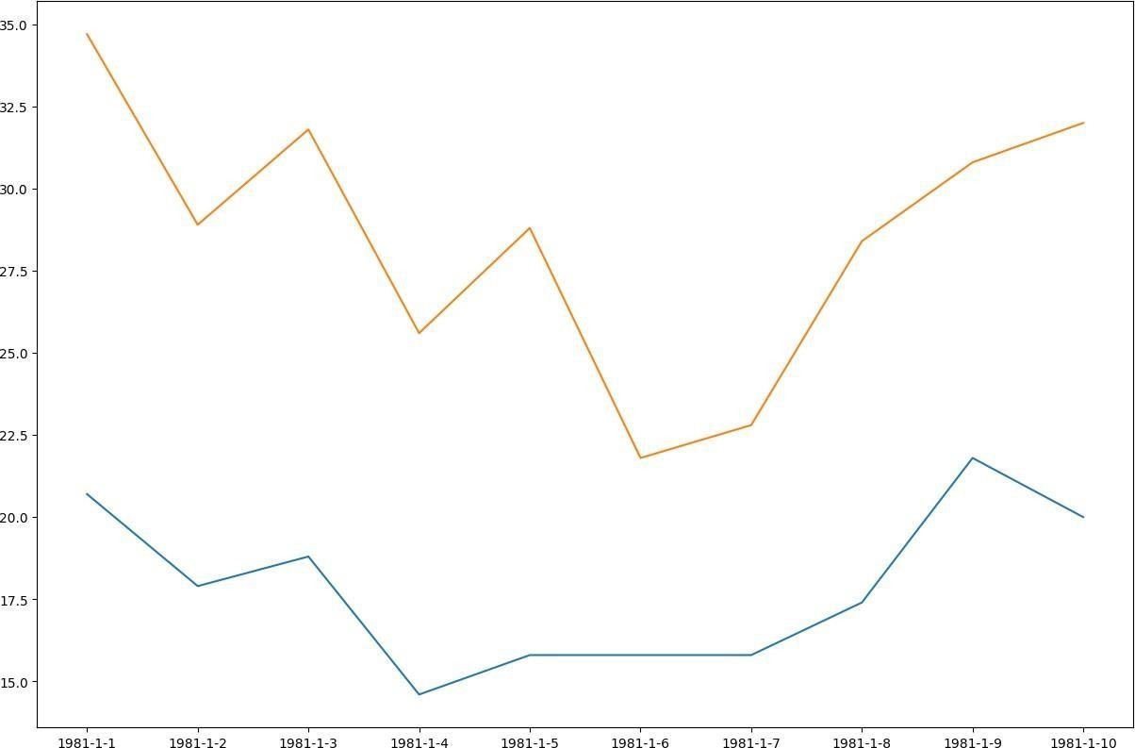axes.plot(dates,max_temperature, label='Max temperature') axes.legend

|  |  |  |
| --- | --- | --- |
| def legend(*args, **kwargs) | | |
| /usr/local/lib/python3.10/dist-packages/matplotlib/axes/_axes.py |  |  |
| Place a legend on the Axes.  Call signatures:: |
|  | |  |

matplotlib.axes._axes.Axes.legend sns.set() x = np.linspace(0,10,1000)

plt.plot(x, np.sin(x), x, np.cos(x))

 [<matplotlib.lines.Line2D at 0x7e3acaaaffa0>,

<matplotlib.lines.Line2D at 0x7e3acaae0040>]

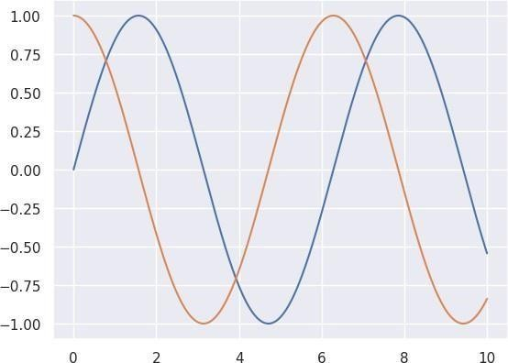

sns.set(style="dark")

fig, ax = plt.subplots(ncols=2, nrows=1, figsize=(15,10)) df= sns.load_dataset("tips") print(df.head())

sns.lineplot(x="total_bill", y="tip", hue="size", style= "time", data=df,ax=ax[0]).set_title("Line Plot")

sct_plt = sns.scatterplot(x="total_bill", y="tip", hue="size", style="time", data=df, ax=ax[1]).set_title("Scatter Plot") sct_plt.figure.savefig('Scatter_plot1.png') print('Plot Saved')

 total_bill tip sex smoker day time size

|  |  |  |
| --- | --- | --- |
| 16.99 1.01 Female | No Sun Dinner | 2 |
| 10.34 1.66 Male | No Sun Dinner | 3 |
| 21.01 3.50 Male | No Sun Dinner | 3 |
| 23.68 3.31 Male | No Sun Dinner | 2 |
| 24.59 3.61 Female | No Sun Dinner | 4 |

Plot Saved

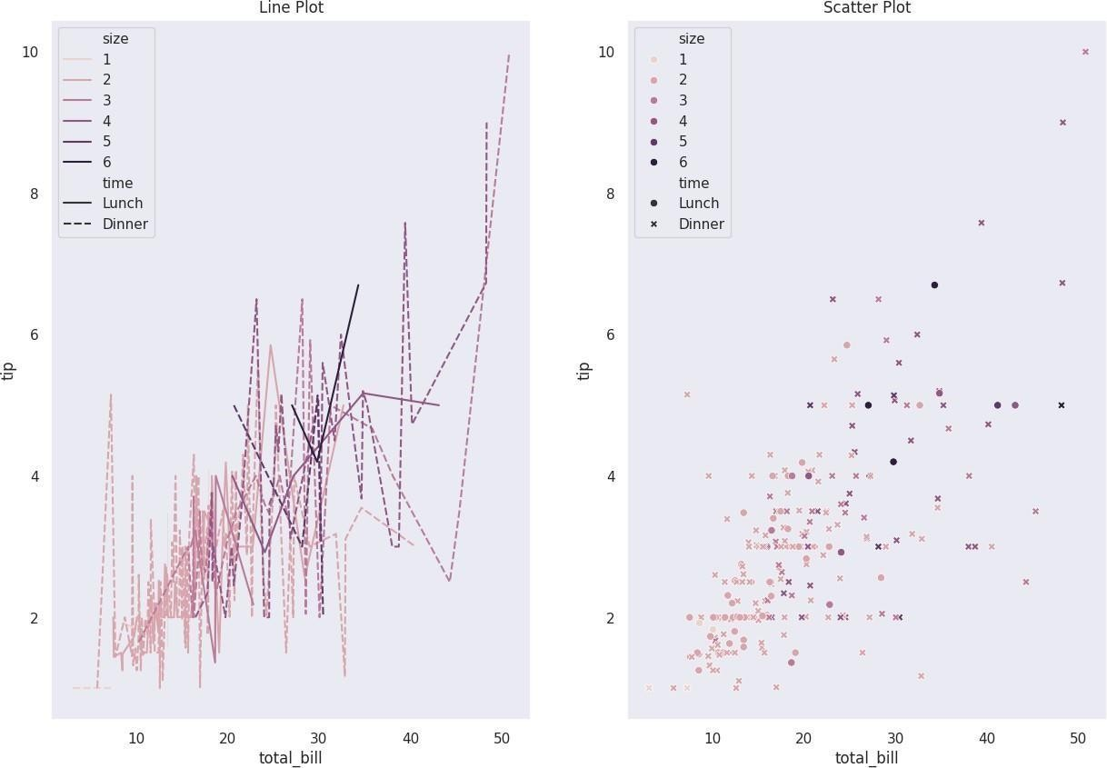

sns.set_style('darkgrid')

fig, ax = plt.subplots(nrows=5, ncols=2) fig.set_size_inches(18.5, 10.5)

df=sns.load_dataset('tips')

sns.barplot(x='sex', y='total_bill', data=df, palette='plasma', estimator= np.std, ax=ax[0,0]).set_title('Bar Plot') sns.countplot(x='sex', data=df, ax=ax[0,1]).set_title('Count plot')

sns.boxplot(x='day', y='total_bill', data=df, hue='smoker', ax=ax[1,0]).set_title('Box Plot')

sns.violinplot(x='day', y='total_bill', data=df, hue='sex', split= True, ax=ax[1,1]).set_title('Violin plot')

sns.stripplot(x='day', y='total_bill', data=df, jitter= True, hue='smoker', dodge=True, ax=ax[2,0]).set_title('Strip Plot') sns.swarmplot(x='day', y='total_bill', data=df, ax=ax[2,1]).set_title('Swarm plot')

sns.violinplot(x='day', y='total_bill', data=df, ax=ax[3,0]) sns.swarmplot(x='day',y='total_bill',data=df, color='black', ax=ax[3,0]).set_title('Combined plot') sns.barplot(x='tip',y='total_bill', data=df, ax=ax[3,1])

sns.boxenplot(x="day", y="total_bill", color="b", scale="linear", data=df, ax=ax[4,0]) sns.pointplot(x="day", y="total_bill", color="b", hue="sex", data=df, ax=ax[4,1]) sns.catplot(x='day',y='total_bill',data=df, kind='bar')  <ipython-input-6- 79e72dcff921>:7: FutureWarning:

Passing `palette` without assigning `hue` is deprecated and will be removed in v0.14.0. Assign the `x` variable to `hue` and set `l sns.barplot(x='sex', y='total_bill', data=df, palette='plasma', estimator= np.std, ax=ax[0,0]).set_title('Bar Plot') <ipython-input-6- 79e72dcff921>:24: FutureWarning:

The `scale` parameter has been renamed to `width_method` and will be removed in v0.15. Pass `width_method='linear' for the same eff sns.boxenplot(x="day", y="total_bill", color="b", scale="linear", data=df, ax=ax[4,0]) <ipython-input-6- 79e72dcff921>:26: FutureWarning:

Setting a gradient palette using color= is deprecated and will be removed in v0.14.0. Set

`palette='dark:b'` for the same effect. sns.pointplot(x="day", y="total_bill", color="b", hue="sex", data=df, ax=ax[4,1])

<seaborn.axisgrid.FacetGrid at 0x7e3ac3b802e0>

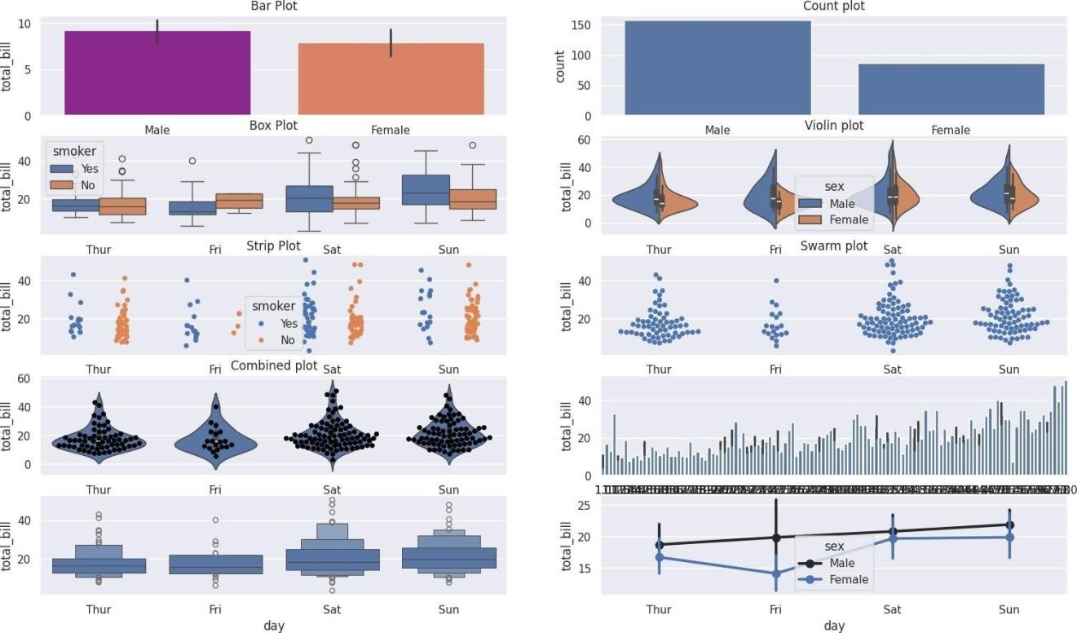

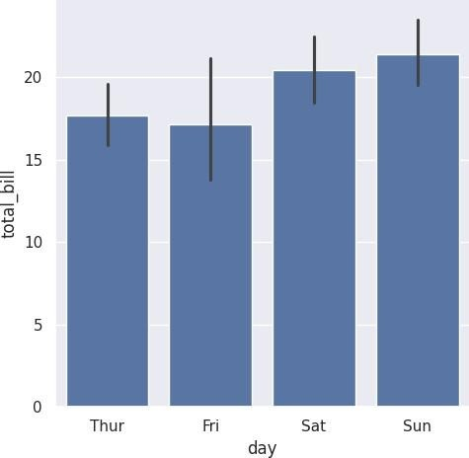

sns.set_style('whitegrid')

#loading the dataset directly without any files df=sns.load_dataset('iris') print(df.head())

 sepal_length sepal_width petal_length petal_width species

|  |  |  |  |  |  |
| --- | --- | --- | --- | --- | --- |
| 0 | 5.1 | 3.5 | 1.4 | 0.2 | setosa |
| 1 | 4.9 | 3.0 | 1.4 | 0.2 | setosa |
| 2 | 4.7 | 3.2 | 1.3 | 0.2 | setosa |
| 3 | 4.6 | 3.1 | 1.5 | 0.2 | setosa |
| 4 | 5.0 | 3.6 | 1.4 | 0.2 | setosa |

sns.distplot(df['petal_length'], kde=True, color='red', bins=30).set_title('Dist plot')  <ipython-input-8-6c2fae3a6ad9>:1: UserWarning:

`distplot` is a deprecated function and will be removed in seaborn v0.14.0.

Please adapt your code to use either `displot` (a figure-level function with similar flexibility) or `histplot` (an axes-level function for histograms).

For a guide to updating your code to use the new functions, please see <https://gist.github.com/mwaskom/de44147ed2974457ad6372750bbe5751>

sns.distplot(df['petal_length'], kde=True, color='red', bins=30).set_title('Dist plot') Text(0.5, 1.0, 'Dist plot')

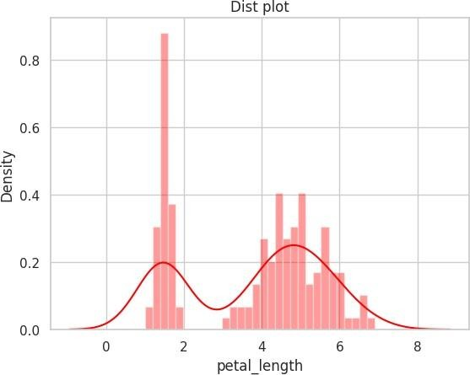

jointgrid = sns.JointGrid(x='petal_length', y='petal_width', data=df) jointgrid.plot_joint(sns.scatterplot) jointgrid.plot_marginals(sns.distplot)  /usr/local/lib/python3.10/dist- packages/seaborn/axisgrid.py:1886: UserWarning:

`distplot` is a deprecated function and will be removed in seaborn v0.14.0.

Please adapt your code to use either `displot` (a figure-level function with similar flexibility) or `histplot` (an axes-level function for histograms).

For a guide to updating your code to use the new functions, please see <https://gist.github.com/mwaskom/de44147ed2974457ad6372750bbe5751> func(self.x, **orient_kw_x,

**kwargs)

/usr/local/lib/python3.10/dist-packages/seaborn/axisgrid.py:1892: UserWarning:

`distplot` is a deprecated function and will be removed in seaborn v0.14.0.

Please adapt your code to use either `displot` (a figure-level function with similar flexibility) or `histplot` (an axes-level function for histograms). For a guide to updating your code to use the new functions, please see <https://gist.github.com/mwaskom/de44147ed2974457ad6372750bbe5751>

func(self.y, **orient_kw_y, **kwargs)

<seaborn.axisgrid.JointGrid at 0x7e3b00f8d120>

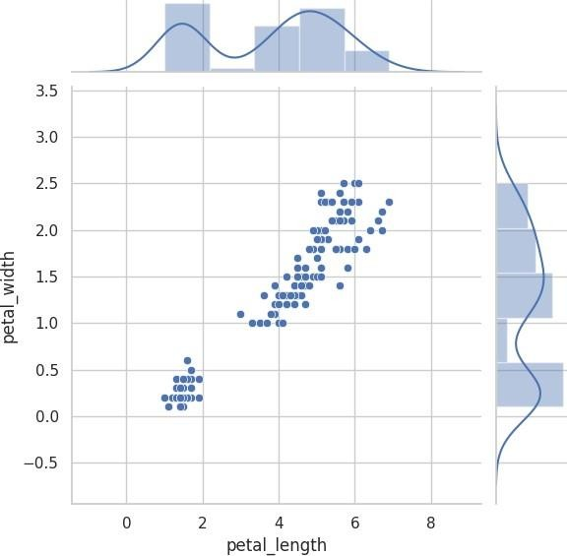

g=sns.jointplot(x='petal_length', y= 'petal_width', data=df, kind='hex') g.fig.suptitle('Joint Plot')

Text(0.5, 0.98, 'Joint Plot')



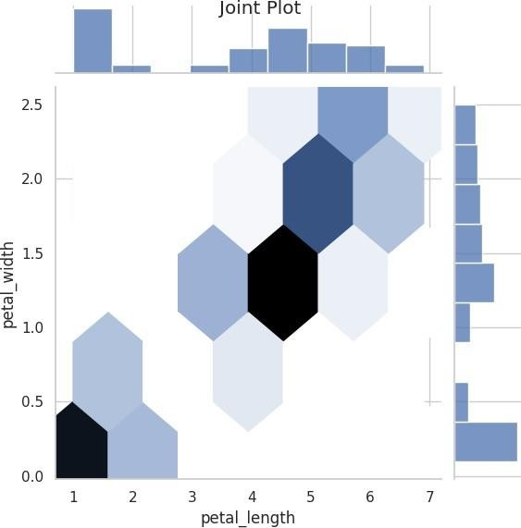

g=sns.pairplot(df, hue="species", palette= 'coolwarm') g.fig.suptitle("Pair Plot 1") g.add_legend

|  |  |
| --- | --- |
| seaborn.axisgrid.Grid.add_legend  def add_legend(legend_data=None, title=None, label_order=None, adjust_subtitles=False, **kwargs) | |
| /usr/local/lib/python3.10/dist-packages/seaborn/axisgrid.py Draw a legend, maybe placing it outside axes and resizing the figure.  Parameters |  |
|  |
|  |
| legend_data : dict |  |

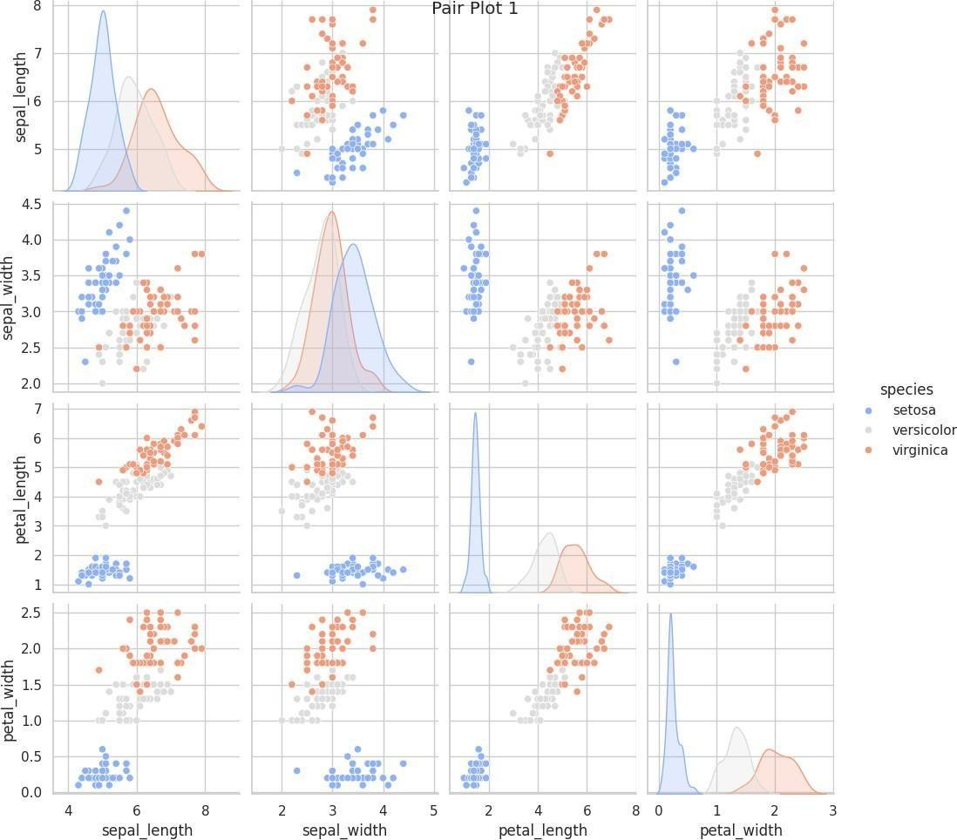

pairgrid= sns.PairGrid(data=df)

pairgrid= pairgrid.map_offdiag(sns.scatterplot) pairgrid= pairgrid.map_diag(plt.hist)

pairgrid = sns.PairGrid(data=df)

pairgrid = pairgrid.map_upper(sns.scatterplot) pairgrid = pairgrid.map_diag(plt.hist) pairgrid = pairgrid.map_lower(sns.kdeplot)

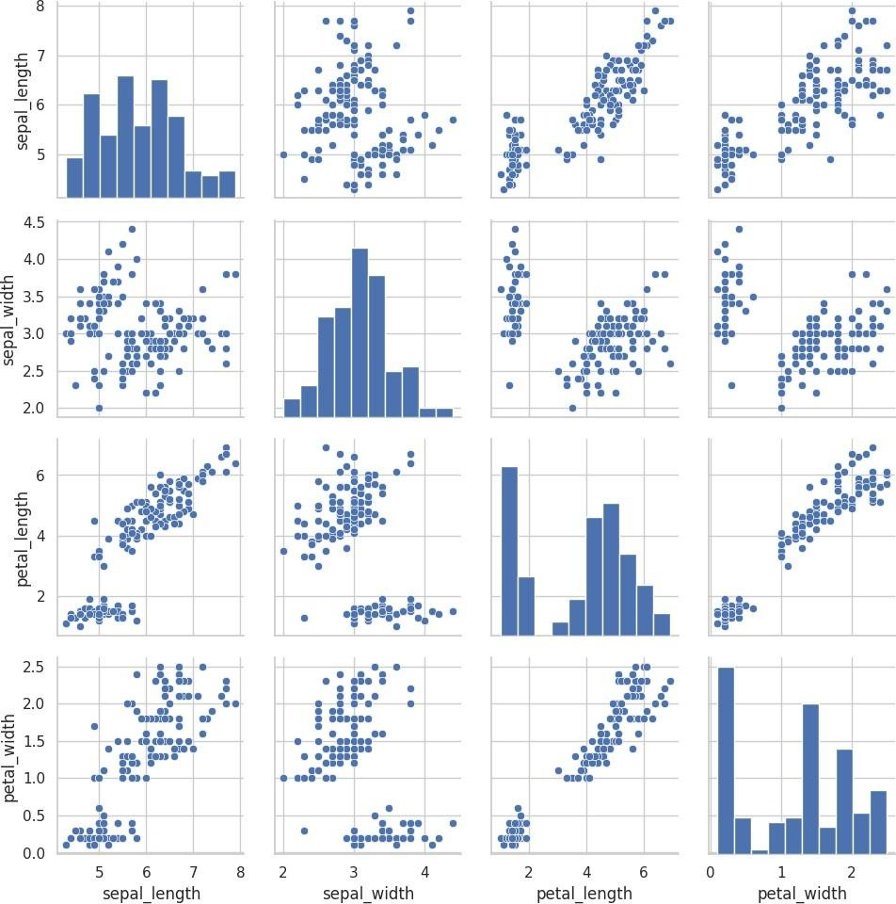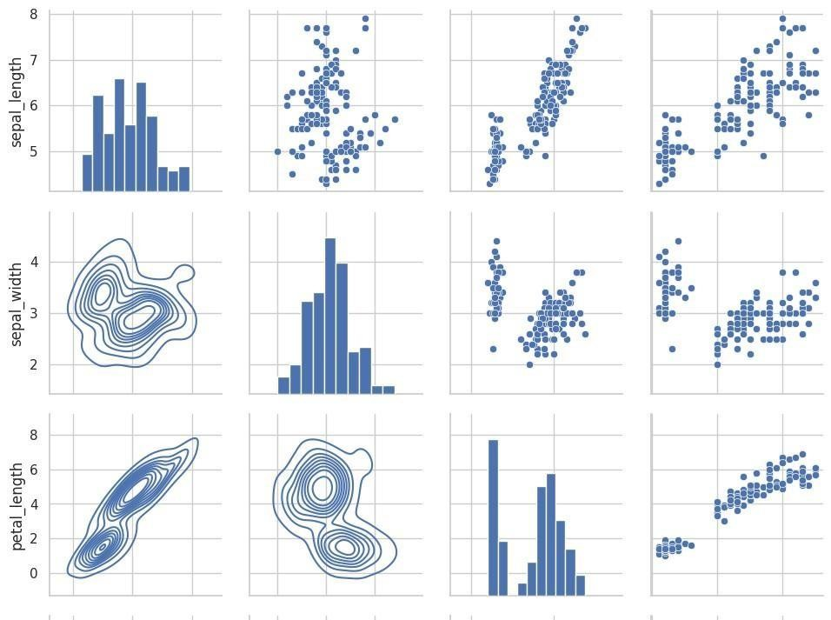

# LABSHEET-12 TEXT VISUALIZATION

import pandas as pd import matplotlib.pyplot as plt from wordcloud import WordCloud from wordcloud import STOPWORDS

df= pd.read_csv('/content/netflix_titles.csv', usecols=['cast']) df.head()

cast NaN

Ama Qamata, Khosi Ngema, Gail Mabalane, Thaban...

Sami Bouajila, Tracy Gotoas, Samuel Jouy, Nabi... NaN

Mayur More, Jitendra Kumar, Ranjan Raj, Alam K...

ndf=df.dropna() ndf.head() cast

Ama Qamata, Khosi Ngema, Gail Mabalane, Thaban...

Sami Bouajila, Tracy Gotoas, Samuel Jouy, Nabi... Mayur More, Jitendra Kumar, Ranjan Raj, Alam K... Kate Siegel, Zach Gilford, Hamish Linklater, H... Vanessa Hudgens, Kimiko Glenn, James Marsden, ...

text= " ".join(item for item in ndf['cast']) print(text)

 Ama Qamata, Khosi Ngema, Gail Mabalane, Thabang Molaba, Dillon Windvogel, Natasha Thahane, Arno Greeff, Xolile Tshabalala, Getmore

stopwords = set(STOPWORDS)

wordcloud = WordCloud(background_color="White").generate(text) plt.imshow(wordcloud, interpolation= 'bilinear') plt.axis("off")

plt.margins(x=0, y=0) plt.show()



wordcloud = WordCloud(background_color="White", max_words=100, max_font_size=300, width= 800, height=500, colormap="magma").generate(te plt.figure(figsize=(20,20)) plt.imshow(wordcloud, interpolation= 'bilinear') plt.axis("off") plt.margins(x=0, y=0) plt.show()

 

# LABSHEET-13 TIME SERIES DATA

A time series is the series of data points listed in time order.

A time series is a sequence of successive equal interval points in time.

A time-series analysis consists of methods for analyzing time series data in order to extract meaningful insights and other useful characteristics of data. For performing time series analysis download stock_data.csv

import pandas as pd import numpy as np import matplotlib.pyplot as plt

# reading the dataset using read_csv

df = pd.read_csv("/content/stock_data.csv", parse_dates=True, index_col="Date") # displaying the first five rows of dataset df.head()

Open High Low Close Volume Name 

**Date**

**2006-01-03** 39.69 41.22 38.79 40.91 24232729 AABA

**2006-01-04** 41.22 41.90 40.77 40.97 20553479 AABA

**2006-01-05** 40.93 41.73 40.85 41.53 12829610 AABA

**2006-01-06** 42.88 43.57 42.80 43.21 29422828 AABA **2006-01-09** 43.10

43.66 42.82 43.42 16268338 AABA

Nextsteps:

Generate code with df



View recommendedplots

We have used the ‘parse_dates’ parameter in the read_csv function to convert the ‘Date’ column to the DatetimeIndex format. By default, Dates are stored in string format which is not the right format for time series data analysis.

Now, removing the unwanted columns from dataframe i.e. ‘Unnamed: 0’.

# deleting column df=df.drop(columns='Name') print(df)

Open High Low Close Volume

Date

2006-01-03 39.69 41.22 38.79 40.91 24232729

2006-01-04 41.22 41.90 40.77 40.97 20553479

2006-01-05 40.93 41.73 40.85 41.53 12829610

2006-01-06 42.88 43.57 42.80 43.21 29422828

2006-01-09 43.10 43.66 42.82 43.42 16268338

... ... ... ... ... ... 2014-12-23 51.46 51.46 49.93 50.02 15514036

2014-12-24 50.19 50.92 50.19 50.65 5962870

2014-12-26 50.65 51.06 50.61 50.86 5170048

2014-12-29 50.67 51.01 50.51 50.53 6624489 2014-12-30

50.35 51.27 50.35 51.22 10703455

[2263 rows x 5 columns]

Example 1: Plotting a simple line plot for time series data. df['Volume'].plot()

<Axes: xlabel='Date'>



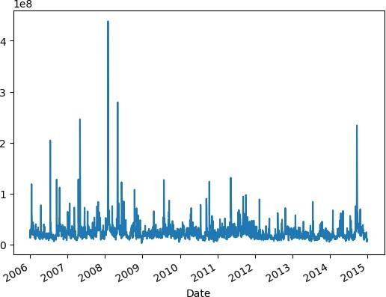

Example 2: Now let’s plot all other columns using subplot.

df.plot(subplots=True, figsize=(10, 12))  array([<Axes: xlabel='Date'>, <Axes:

xlabel='Date'>,

<Axes: xlabel='Date'>, <Axes: xlabel='Date'>,

<Axes: xlabel='Date'>], dtype=object)

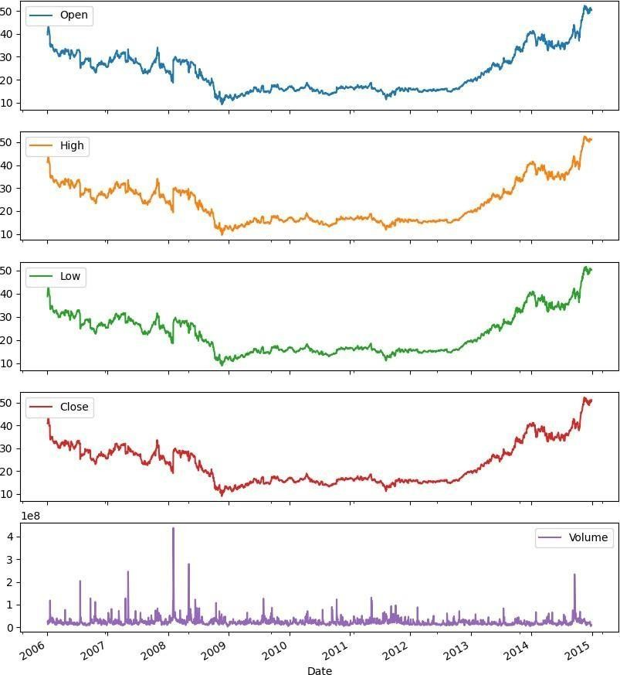

Resampling: Resampling is a methodology of economically using a data sample to improve the accuracy and quantify the uncertainty of a population parameter. Resampling for months or weeks and making bar plots is another very simple and widely used method of finding

seasonality. Here we are going to make a bar plot of month data for 2016 and 2017. Example 3:

# Resampling the time series data based on monthly 'M' frequency df_month

= df.resample("M").mean() print(df_month)

# using subplot

fig, ax = plt.subplots(figsize=(10, 6))

# plotting bar graph

ax.bar(df_month['2012':'2014'].index, df_month.loc['2012':'2014', "Volume"],width=25, align='center')

 Open High Low Close Volume Change Date

2006-01-31 38.245500 38.694000 37.641500 38.113000 3.400594e+07 0.991442

2006-02-28 33.141579 33.436842 32.627368 32.975789 2.329848e+07 0.996423

2006-03-31 31.333478 31.696957 30.929130 31.218696 2.095522e+07 1.000390

2006-04-30 32.383684 32.790000 31.914737 32.283158 2.200768e+07 1.001098

2006-05-31 31.744545 32.175455 31.171364 31.517273 2.218047e+07 0.998535

... ... ... ... ... ... ... 2014-08-31 36.836190 37.150000 36.545238 36.876667 1.396539e+07 1.003530

2014-09-30 40.662857 41.270000 39.983810 40.671905 5.811769e+07 1.003005

2014-10-31 41.253043 41.886087 40.784783 41.393913 3.210848e+07 1.005501

2014-11-30 49.879474 50.553158 49.440000 50.151579 2.474402e+07 1.006233

2014-12-31 50.359524 50.975714 49.852857 50.331905 1.623090e+07 0.999653

[108 rows x 6 columns]

<BarContainer object of 36 artists>

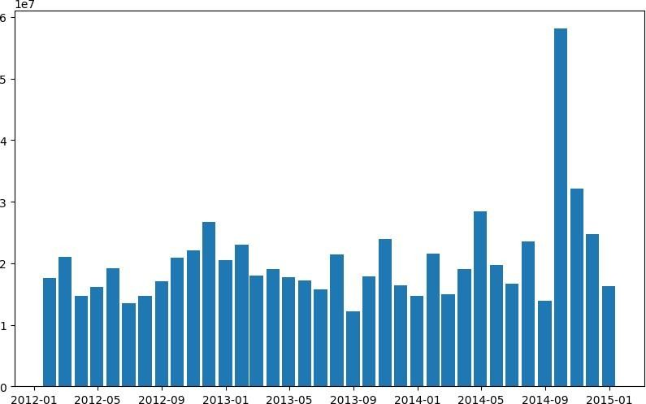

Differencing: Differencing is used to make the difference in values of a specified interval. By default, it’s one, we can specify different values for plots. It is the most popular method to remove trends in the data.

df.Low.diff(2).plot(figsize=(10, 6))

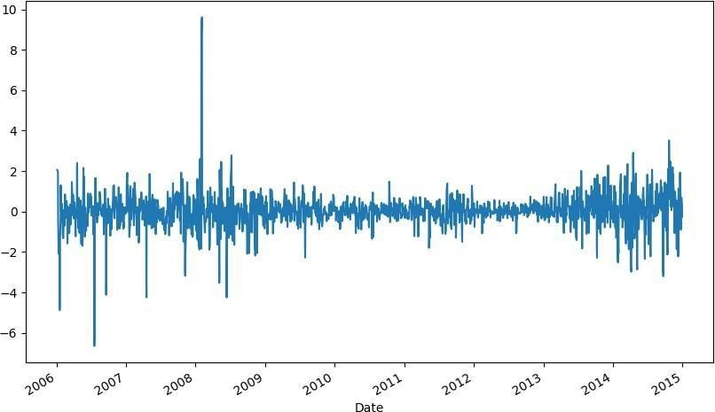

df.High.diff(2).plot(figsize=(10, 6))

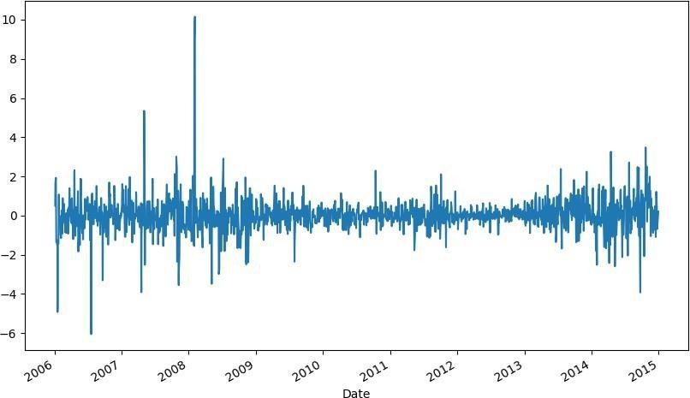<Axes: xlabel='Date'>

Plotting the Changes in Data

We can also plot the changes that occurred in data over time. There are a few ways to plot changes in data.

Shift: The shift function can be used to shift the data before or after the specified time interval. We can specify the time, and it will shift the data by one day by default.

That means we will get the previous day’s data. It is helpful to see previous day data and today’s data simultaneously side by side.

df['Change'] = df.Close.div(df.Close.shift()) df['Change'].plot(figsize=(10, 8), fontsize=16)

values. Actually, div() means

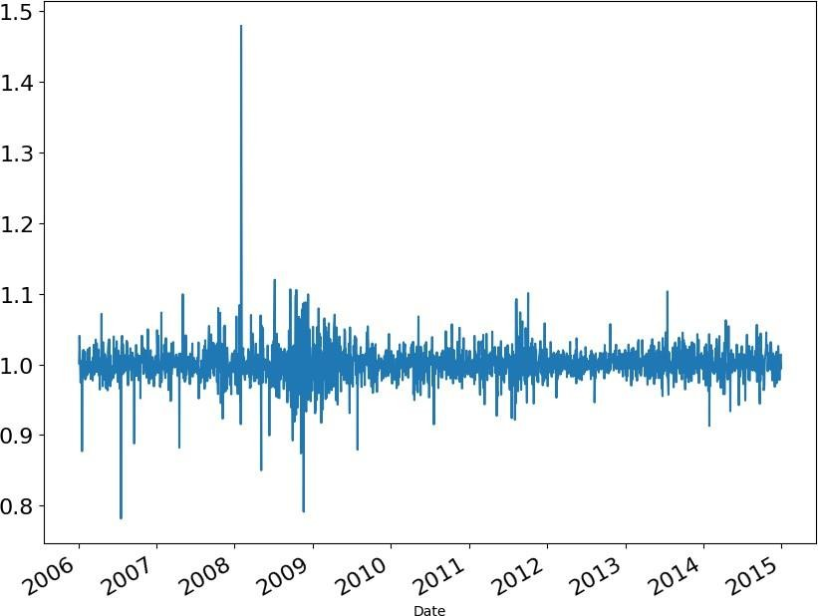

.div() function helps to fill up the missing data

division. If we take df. div(6) it will divide each element in df by 6.

We do this to avoid the null or missing values that are created by the ‘shift()’

operation.

df['Change'].plot(figsize=(10, 6))

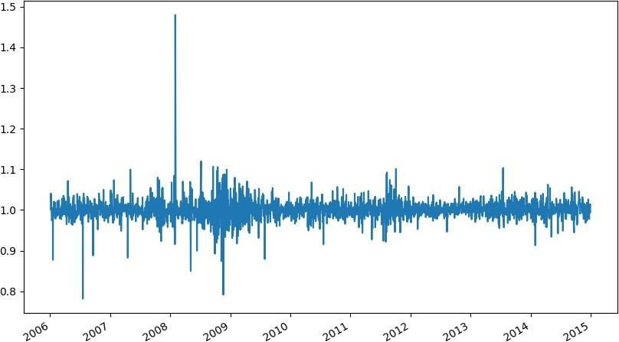<Axes: xlabel='Date'>